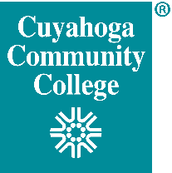 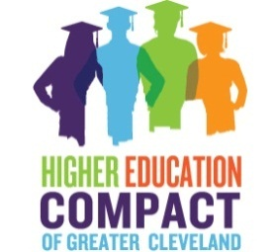 

**Cuyahoga Community College’s Focus on Student Success and Completion**

**Tri-C is partnering with the Mayor of Cleveland and the Cleveland Metropolitan School District (CMSD) to support and guide CMSD graduates on their pathway to successful completion of a certificate or degree at Cuyahoga Community College.**

**Intentional Student Support Initiatives Include:**

* **Mandatory Placement test preparation** to encourage placement at the highest levels of math and English and move students into college level coursework faster.
* **Two Week Intensive “Bridge” programs** to prepare eligible students for college-level English and math and encourage successful and timely completion of coursework.
* **Mandatory In-person New Student Orientation and Peer Mentors** to engage students with a peer who can help them learn how to navigate Tri-C.
* **Strategic Enrollment in Developmental Coursework** starting the first semester.
* **Supplemental Instructor (SI)** in developmental math courses to provide extra support and tutoring.
* **General Studies Course** during the first semester to better prepare students for success in college.
* **Early Alert System** in developmental English and math courses to connect students with support in and out of the classroom early in the term.
* **A Case Management Approach with our Student Success Specialists** so students on each campus have a point-person to assist with questions or concerns.
* **Mandatory Advising Prior to the Second Semester** so students continue with their developmental course sequences and stay on the most direct route to completion.
* **Continuous Monitoring of Student Progress and Credit Hours** to provide real-time outreach for students falling behind in academic progress or dropping courses.

**As a result of a coordinated and intentional effort on the part of both academic and student affairs, Cuyahoga Community College has reshaped the student experience in a new and integrated model to support student persistence.**