UW Colleges, UW-Extension Comprehensive Student Record Project
SmartScript Competency Record for the Flexible Option AAS Degree
November 2016

- Default View

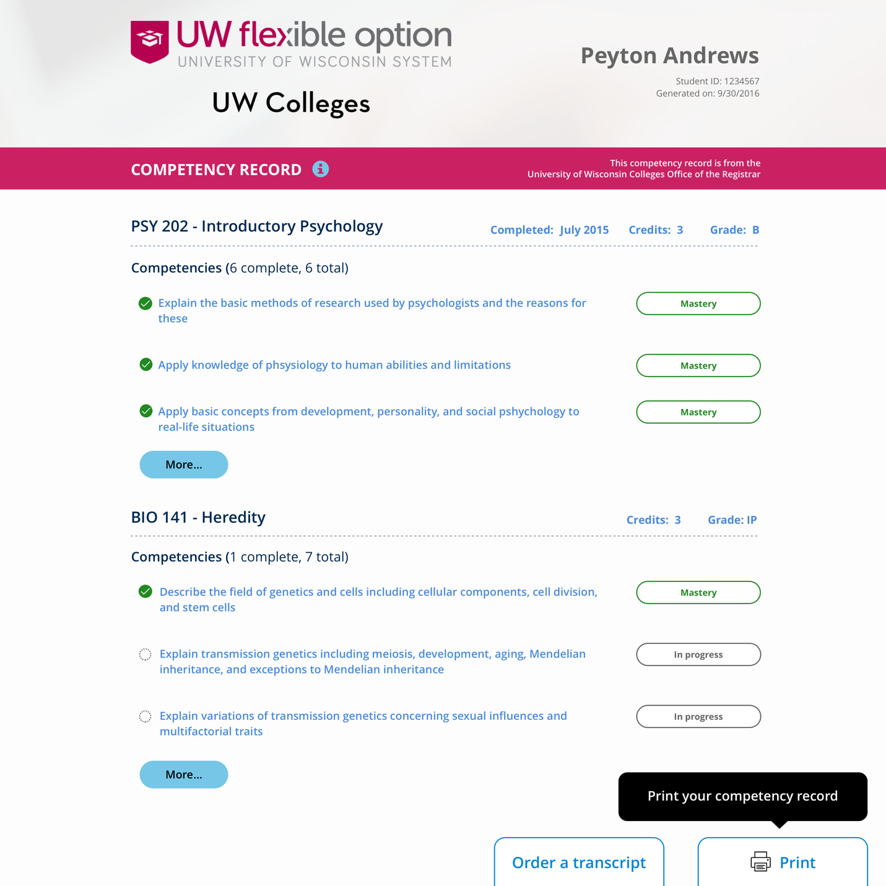

- Expanded View
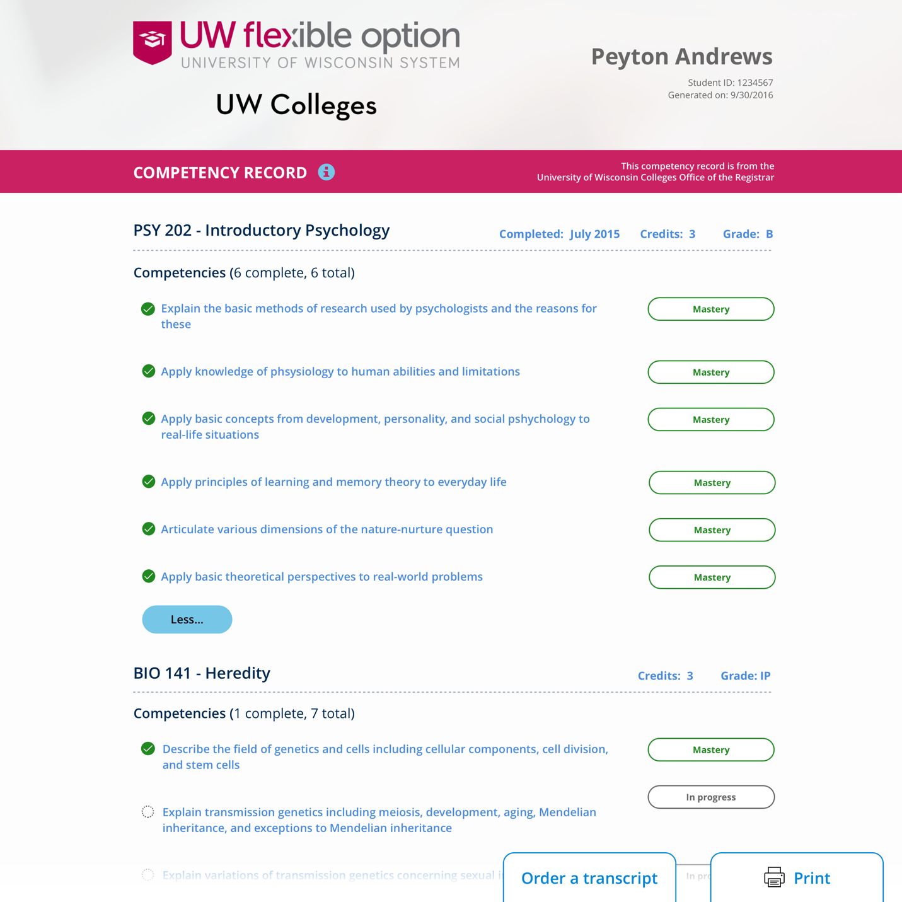

- Mobile Device View
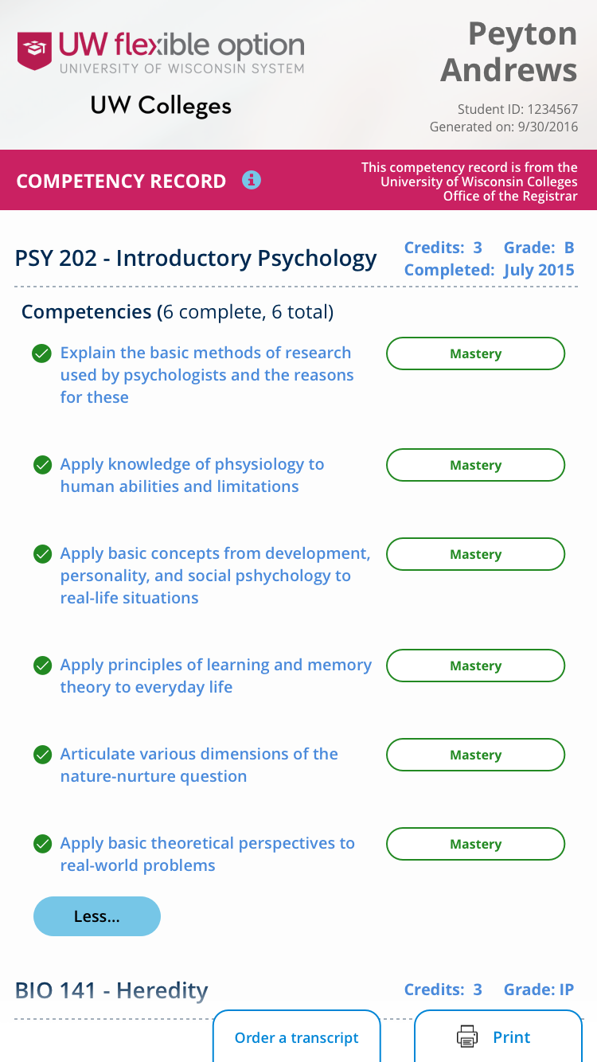
- Print View
